Project Design Phase-II
Data Flow Diagram & User Stories

Data Flow Diagrams:
Example: DFD Level 0 ( Visualizing Housing Market Trends)
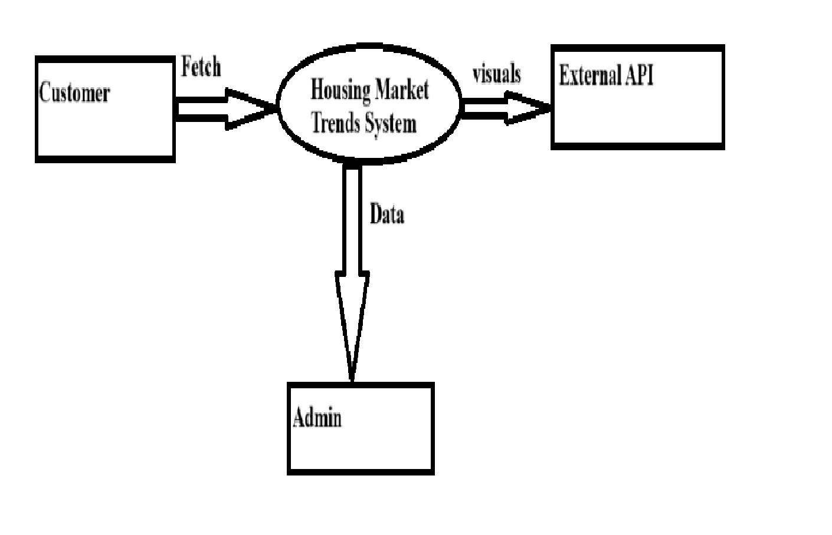
A Data Flow Diagram (DFD) is a traditional visual representation of the information flows within a system. A neat and clear DFD can depict the right amount of the system requirement graphically. It shows how data enters and leaves the system, what changes the information, and where data is stored.

Example: (Simplified)
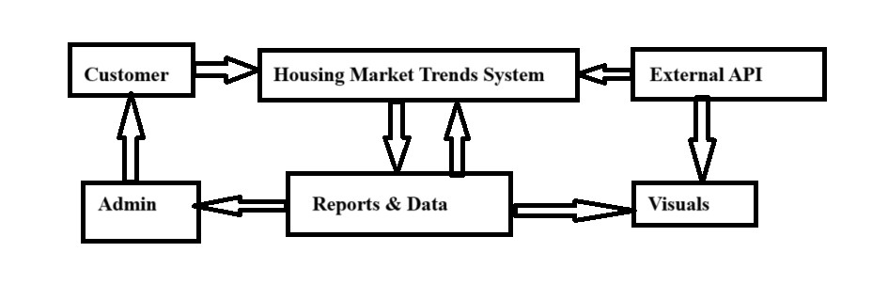

User Stories
Use the below template to list all the user stories for the product.
User Type | Functional  Requirement  (Epic) | User Story  Number | User Story / Task | Acceptance criteria | Priority | Release
Customer | Upload Housing Data | USN-1 | As a user, I can upload CSV files containing housing market data. | File successfully uploaded and previewed. | High | Sprint-1
Customer | Fetch Data From API | USN-2 | As a user, I can fetch housing data from external APIs. | Data is successfully fetched and displayed. | Medium | Sprint-2
Customer | Clean & Process Data | USN-3 | As a user, I can apply filters & transformation to clean raw data. | Data is properly cleaned (e.g., missing values handled). | High | Sprint-2
Customer | View  Visualizations | USN-4 | As a user, I can view housing market trends through interactive graphs and charts. | Dashboard is visible with visualized KPIs. | High | Sprint-2
Customer | Save & Export Reports | USN-5 | As a user, I can download the generated reports in PDF/CSV format. | File is downloaded with relevant charts/data. | Medium | Sprint-3
Admin | Manage Users | USN-6 | As an admin, I can view and manage registered users. | Admin can see user list, delete or deactivate accounts | Low | Sprint-3
Customer | Dashboard  Filtering | USN-7 | As a user, I can filter the dashboard results by city, price range, or year. | Charts update dynamically with selected filters. | High | Sprint-2
Admin | View Usage  Analytics | USN-8 | As a admin , I can view how many users are using each feature. | Graph of feature usage is visible. | Low | Sprint-3

